Barry J.C. Purves is an English animator, director and writer of puppet animation and also a designer and director of stage plays, primarily for the Altrincham Garrick Playhouse in Manchester. Known as one of Britain's most celebrated animators on account of his six short films, each of which has been nominated for numerous international awards (including Academy Award and British Academy Film Awards nominations). He has also directed and animated for several television programs and over seventy advertisements, title sequences and animated insert sequences for feature films. His film credits include being head animator for Tim Burton's Mars Attacks! (Before the decision was made to use computer animation in place of stop motion), previsualization animation director for Peter Jackson's King Kong and being "casually involved," simultaneous to this, with animation for the same director's The Lord of the Rings: The Return of the King during the 2003 film's post-production.
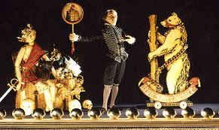

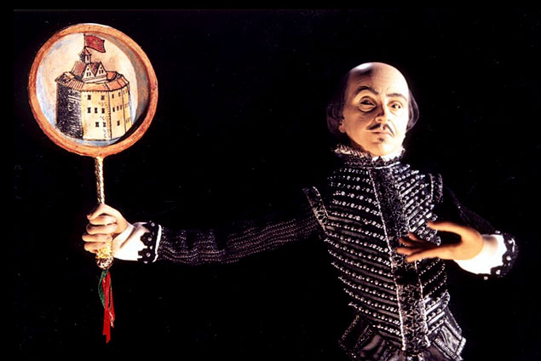

Stills from the animation Next which won an award
Eric Fogel (born 1969) is a Salvadorean director, writer, producer and voice actor who is best known as the creator of the TV series Celebrity Deathmatch.



Glenn Martin, DDS

Dave Johnson The Koala Brothers
The show was originated by Dave Johnson and brought to our screens by Spellbound Entertainment and Famous Flying Films.
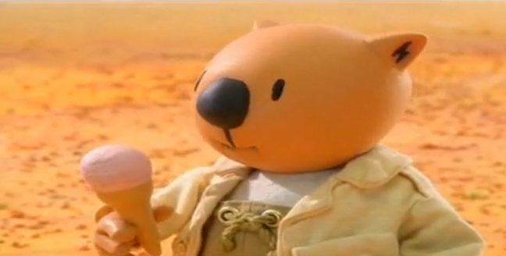

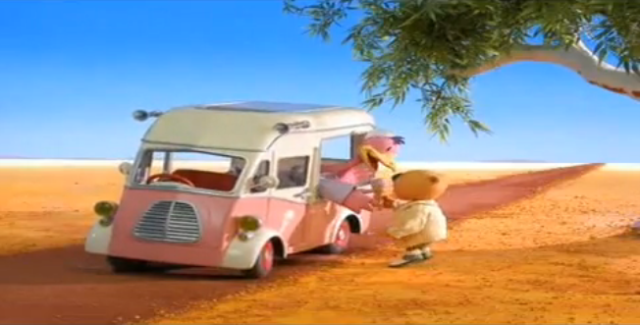

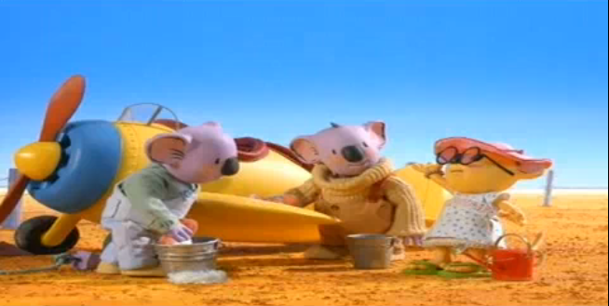

Nick Hilligoss is an Australian stop motion animator working with modelling and animation, with many past projects for Australian Broadcasting Corporation and ABC Natural History Unit in Melbourne. Hilligoss has received many awards for his animations.



