

Michael Craig "Mike" Judge (born October 17, 1962) is an American animator, film director and voice actor, best known as the creator and star of the popular animated television series Beavis and Butt-head (1993–1997), King of the Hill (1997–2009), and The Goode Family (2009)

The Goode Family screen shots
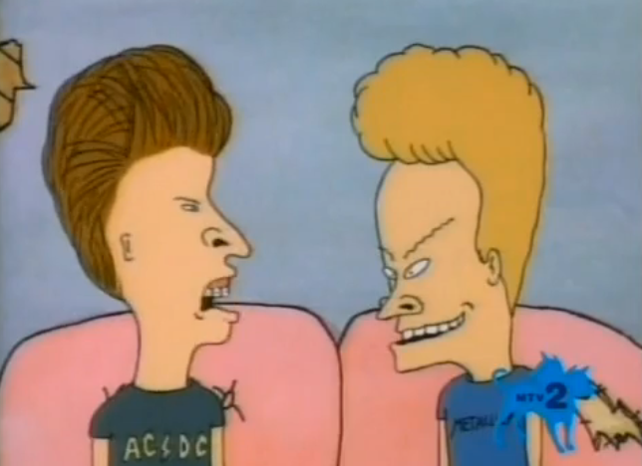




Beavis and Butt-head (1993–1997)

